# __
Name ______________________________
Date _______________ Class __________
Wind

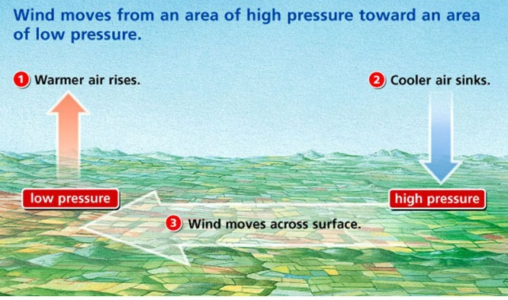
Weather, the condition of Earth’s atmosphere at a particular time and place, can have a big impact on you; what you decide to wear each day, if you need to carry an umbrella or not, and even if there are precautions you need to take. The news that we see is often related to the weather that is being forecasted and the effects of weather that has passed; hurricane damage, flooding, etc. Whether a gentle breeze that rustles the leaves on a tree or a strong hurricane that topples the entire tree, wind is an important part of weather.
Wind is produced by the uneven heating of the Earth’s
surface by the sun. Since the Earth’s surface is made of various
land and water formations, it absorbs the sun’s radiation unevenly.
The uneven heating of Earth’s surface on both a local and global
level, creates differences in temperature. These differences in
temperature cause differences in air pressure and these
differences in air pressure create wind. Wind is the horizontal
movement of air from areas of high pressure to areas of lower
pressure.
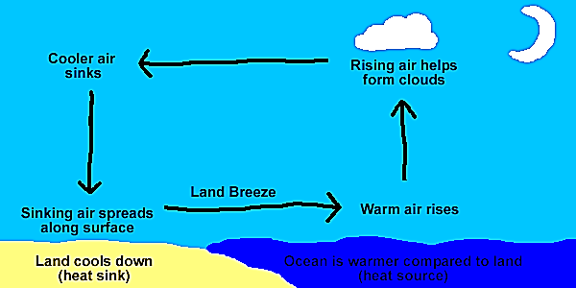
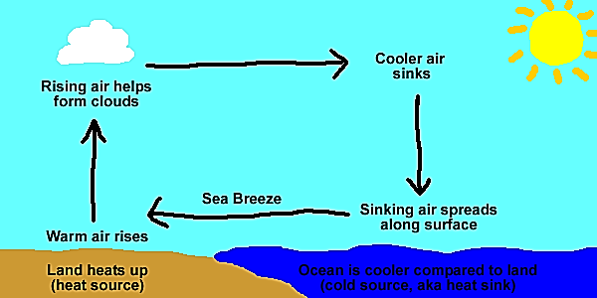
Winds are grouped into two main categories, local winds and global winds. Local winds are winds that blow within a small area and are often influenced by terrain. Some common local winds are sea and land breezes and valley and mountain breezes. These winds are created by the pressure differences that result from the unequal rates of heating between land and water and different land regions. A sea breeze is a local wind where air flows from over water (oceans, seas or large lakes) towards the land. During the day, the land heats up faster than the water. As a result, the air over the land rises and expands creating an area of lower pressure. The cooler, higher pressure air from over the water moves towards the land, creating the sea breeze. During the night, land cools more quickly than the water and the flow of air reverses, creating a land breeze. A land breeze is a local wind where air flows from over land towards the water.

Sea Breeze Land Breeze
Valley breezes and mountain breezes are caused by a similar process. Mountain slopes (like the land by the water) heat up and cool off more quickly than the valleys below them. During the day, valley breezes flow up the mountain and at night, mountain breezes flow down into the valleys.
Both local and global winds are caused by differences in pressure created by the unequal heating of Earth’s surface. However, local winds cover short distances, start and stop quickly and affect the weather in a small area, whereas global winds travel thousands of kilometers around the Earth, last for weeks and influence climates around the world. In areas near the equator, the sun is almost directly overhead for most of the year. These direct rays from the sun heat the Earth’s surface rapidly. The Polar Regions receive much less direct, slanting rays from the sun which results in much less heating of the Earth’s surface in that region. So the warmer, less dense air from the equator rises and moves towards the poles and the colder, denser air from the poles sinks towards the equator. This movement produces a global pattern of air circulation. Global winds are the dominant, prevailing wind patterns that blow in a fairly constant, steady direction across our Earth. However, global winds do not simply flow from north to south or south to north as you might expect because our planet is not stationary. Because the Earth rotates, or spins on its axis, the winds shift directions. Winds in the Northern Hemisphere curve to the right and winds in the Southern Hemisphere curve to the left. This shift in wind direction caused by the rotation of the Earth is called the Coriolis Effect.

The Coriolis Effect is only noticeable in winds that travel long distances. Because the Coriolis Effect causes global winds to curve, they cannot flow directly from the poles to the equator. Instead, global winds travel along three routes or belts in each hemisphere; the Trade Winds, Prevailing Westerlies and Polar Easterlies. Each of these belts is separated by regions of calm winds, the Doldrums and Horse Latitudes.
Trade Winds: These strong, warm, steady winds are found between the equator and the horse latitudes (0° to 30° N and S). These global winds blow from the east towards the west. In the Northern Hemisphere, the Coriolis Effect deflects these winds to the right and in the Southern Hemisphere, they are deflected to the left. In this region, the skies are often clear and there is little rainfall. Hundreds of years ago, the steady winds and fair weather found in this region made this area an ideal sailing route for trading ships traveling between Europe and the Americas, hence the name, Trade Winds. Today, airplane pilots use the trade winds to increase speed and save fuel when traveling east to west in this region.
Prevailing Westerlies: The Prevailing Westerlies are strong winds that blow from the west to the east from around 30° to around 60° north and south latitudes. The Coriolis Effect causes these winds to deflect right in the Northern hemisphere and left in the southern hemisphere. Have you noticed that most of our weather here in the United States travels from the western part of the country across to the eastern part? This is a result of the Westerlies west to east flow carrying weather. When those trading ships mentioned above were ready to return home, they would travel north until they reached the Westerlies which would carry them west back to Europe.
Polar Easterlies: Found from 60° to the poles (90°) north and south latitudes are cold, weak winds called the Polar Easterlies. As you may be able to guess from their name, the Polar Easterlies blow from the east to the west. The Coriolis Effect causes the easterlies in the northern hemisphere to deflect to the right and to deflect left in the southern hemisphere. In the area where the Polar Easterlies and the Prevailing Westerlies meet, the big difference in air pressure often creates stormy weather.
Doldrums: The Doldrums are a low pressure zone near the equator with no wind or very weak winds. The equator receives direct radiant energy from the sun which creates warm, rising air. Normally, cooler high-pressure air would move in, creating wind. However, any air in that does move into this region is warmed so rapidly that this does not occur. If there are any winds here at all, they are very weak. Sailing ships would often get stuck in this region for days or weeks at a time. The definition of doldrums is a state of inactivity and since the ships would definitely become inactive, this is how the Doldrums got their name.
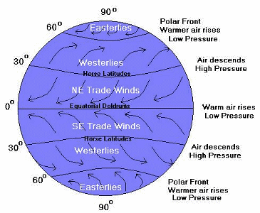
Horse Latitudes: Around 30° North and 30° South is a high-pressure zone with light, unsteady winds. In this region, warm air traveling from the equator cools and sinks. This area tends to be clear and dry. The name of this region also comes from the days of sailing ships, but from a gruesome aspect of this time. The ships would often find themselves stuck in this region for days or even weeks because of the lack of wind or because the winds here do not have a consistent direction of movement. As the days went on, the ships would start to run low on food and water for any horses that they had on board. The horses would be thrown overboard and it was said that the sea was often littered with the bodies of these horses leading to the name Horse Latitudes.

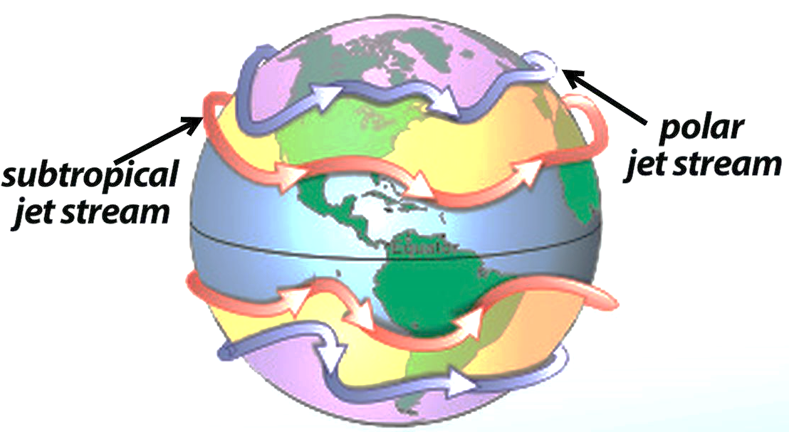
Jet Streams: People have been aware of and using
the global winds for many centuries, but it wasn’t until the
1940s that another kind of long distance wind was
discovered, the Jet Streams. The global winds travel along
Earth’s surface while jet streams travel at higher altitudes in
the Troposphere. Jet streams are narrow bands of high
speed winds that travel west to east at altitudes above
12 kilometers. Wind speeds in the jet streams can reach
180 kilometers per hour (112 mph) in the summer and
350 kph (217mph) in the winter. Airplane pilots traveling
west to east can use the jet stream to increase speed and save fuel. Like global winds, jet streams form as a result of the uneven heating of Earth’s surface, but unlike global winds, jet streams do not flow around the Earth in bands. Instead, jet streams wander up and down as they circle the Earth. At times, they take great detours to the north or the south. Their speed and location vary greatly from season to season and even from day to day. Each hemisphere typically has two jet streams, a polar jet stream and a subtropical jet stream. The polar jet stream has a strong influence on the weather in North America. It can pull cold air down into the United States from Canada or it can pull warm air up towards Canada. In addition, strong storms tend to form along its loops, so meteorologists must know where the jet stream is flowing in order to accurately predict the weather. Both the Prevailing Westerlies and the Jet Stream play a role in the weather in the United States traveling primarily from the west to the east.
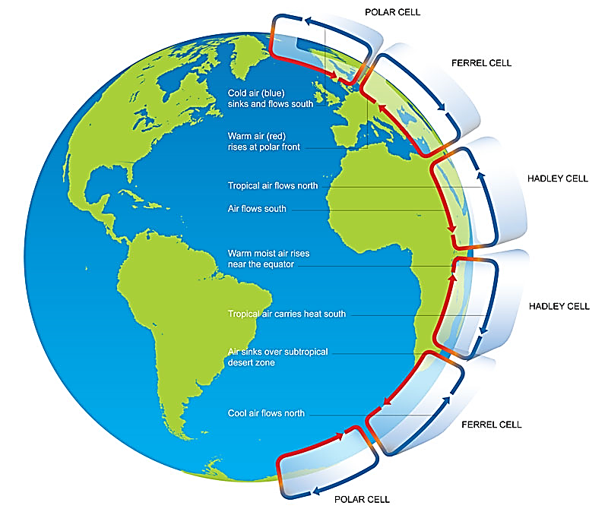
Circulation Cells: Over the major parts
of the Earth's surface there are large-scale wind
circulations present. This global circulation can
be described as the world-wide system of winds
by which the transport of heat from tropical to
polar latitudes is accomplished. These cells are
created by the different temperatures that result
from the unequal heating of the Earth. A
circulation cell is a giant loop of moving air that
includes a global wind belt and the calm regions
that border it. In each hemisphere there are three
cells (Hadley cell, Ferrel cell and Polar cell) in
which air circulates through the entire depth of the
troposphere. In the diagram, notice that the
direction of airflow changes from one cell to
the next.

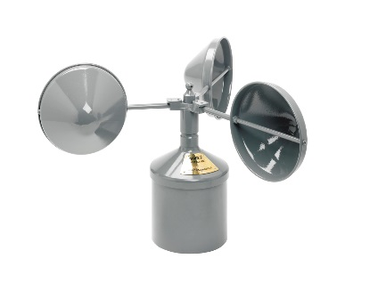
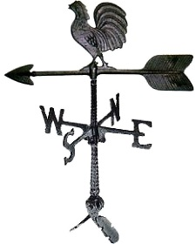
As you have been reading about local and global winds, you have probably noticed that two measurements are used to describe wind; wind direction and wind speed. Meteorologists and weather observers use a wind vane to determine the direction of the wind on Earth’s surface. A wind vane points into the wind. An anemometer is used to measure wind speed. Wind speed is usually expressed in meters per second, miles per hour or knots. One knot is equal to 1.15 miles per hour and is a nautical unit. The highest wind speed ever recorded is over 300mph (Tri-State tornado outbreak in 1999). Scientists do believe that greater speeds have been reached on our planet, but the tools used to measure the speeds simply do not survive winds this great.

Wind vane Anemometer

