Weather and Wind Maps
Name __________________________________
Date ______________________ Item # _______
Air Masses Review
1. Draw and label the Maritime Polar Air Mass that affects the eastern US in BLUE. What type of weather conditions (temperature and moisture) does it bring?
2. Draw and label the Maritime Tropical Air Mass that affects the southeastern US in GREEN. What type of weather conditions (temperature and moisture) does it bring?
3. Draw and label the Maritime Polar Air Mass that affects the western US in BLUE. What type of weather conditions (temperature and moisture) does it bring?
4. Draw and label the Maritime Tropical Air Mass that affects the southwestern US in GREEN. What type of weather conditions (temperature and moisture) does it bring?
5. Draw and label the Continental Polar Air Mass that affects the US in PURPLE. What type of weather conditions (temperature and moisture) does it bring?
6. Draw and label the Continental Tropical Air Mass that affects the US in ORANGE. What type of weather conditions (temperature and moisture) does it bring?
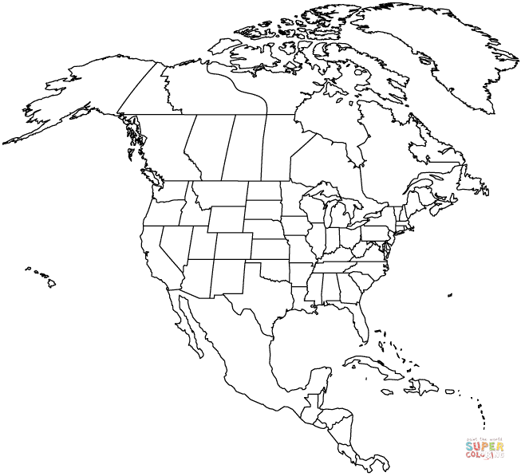

Wind Review
1. Draw a bold RED line at the equator. Label the winds found at the equator.
2. Label 30°N and 30°S. Label 60°N and 60°S.
3. In the Northern hemisphere, label the Westerlies in GREEN.
4. In the Northern hemisphere, label the Polar Easterlies in BLUE.
5. In the Northern hemisphere, label the Trade Winds in ORANGE.
6. Draw and label the Jet Stream that affects the United States in PURPLE. Make sure to include the direction of the wind.
7. Which global winds impact the weather in the United States? In what direction do those winds move air masses?

8. Explain how the Jet Stream impacts weather in the United States.

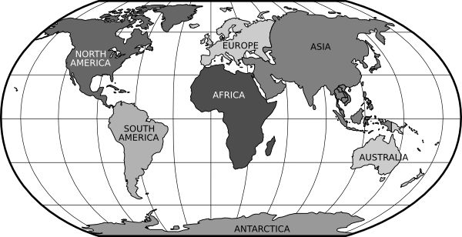

Weather Maps Review
Be sure to use the appropriate colors when labeling your map.
1. Draw a cold front traveling due west from Oregon to southern California.
2. Indicate thunderstorms at the leading edge of the cold front.
3. Draw a stationary front across the middle of Texas. The cold air mass is traveling north and the warm air mass is traveling south. Indicate rain in the area.
4. Draw a warm front heading northwest from northern Florida to North Carolina. Indicate showers in the area.
5. Draw an occluded front from North Dakota to Wisconsin.
6. Draw an area of high pressure over Kansas.
7. Draw an area of low pressure over Maine.
8. If a very cold air mass pushes into the mid-west where a warm air mass is located, what kind of weather could the residents of Oklahoma expect to see?

9. If the Jet Stream was to dip down from Canada into the southeast, what type of weather would it likely bring into the area?
