Hurricanes
What is a hurricane?
A hurricane is a large rotating storm with high speed winds that forms over warm ocean waters. To be classified as a hurricane, a storm must have sustained winds of at least 74 miles per hour. Hurricanes, cyclones, and typhoons are all the same weather phenomenon, but scientists call them different things depending on where they occur. In the Atlantic and northern Pacific, the storms are called Hurricanes, after the Caribbean god of evil, named Hurrican. In the northwestern Pacific, the same powerful storms are called Typhoons and in the southeastern Indian Ocean and southwestern Pacific, they are called Tropical Cyclones.

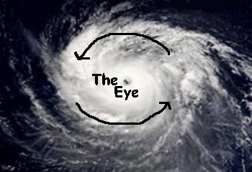
A hurricane is a huge storm. It can be up to 800 miles across and have strong winds spiraling inward and speeds of 75 to over 200 mph. Each hurricane usually lasts for over a week, moving 10-20 miles per hour over the open ocean. Hurricanes gather heat and energy through contact with warm ocean waters. Evaporation from the warm seawater increases their power. Hurricanes rotate in a counter-clockwise direction around an "eye" in the Northern Hemisphere and clockwise direction in the Southern Hemisphere. The center of the storm or "eye" is an area of low pressure and calm winds. When they come onto land, the heavy rain, strong winds and large waves can cause loss of life and damage buildings, trees and cars. However, once on land, hurricanes lose their fuel (warm ocean water) and will lose power.

How do hurricanes form?
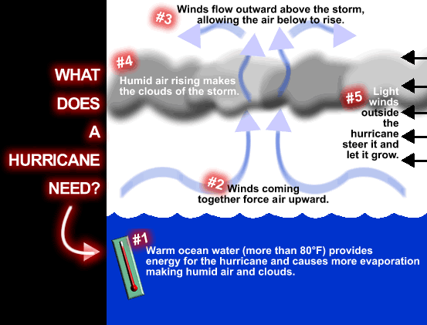
Hurricanes for over the warm ocean waters of the tropics, typically between 5 and 15 degrees latitude north and south of the equator. When the warm, moist air over the water rises, it is replaced with cooler air from higher up in the atmosphere. That cooler air then gets warmed and rises. This pattern leads to the formation of a storm. If this storm continues to grow, the Coriolis Effect will make it start to spin. If there is enough warm water to continue fueling the storm, it will continue to grow and increase in strength.

Hurricane Season:
The Atlantic hurricane season is from June 1st through November 30th. Hurricanes may occur at other times of the year, but they tend to be weaker. The Eastern Pacific hurricane season is from May 15 to November 30.
How are hurricanes named?
From 1950 to 1952, tropical cyclones of the North Atlantic Ocean were identified by the phonetic alphabet (Able-Baker-Charlie-etc.), but in 1953 the US Weather Bureau switched to women's names. The rest of the world eventually caught on, and naming rights now go by the World Meteorological Organization, which uses different sets of names depending on the part of the world the storm is in. Around the U.S., only women's names were used until 1979, when it was decided that they should alternate a list that included men's names too. There are 6 lists of names that are repeated. If a hurricane does significant damage or causes significant loss of life, its name is retired and a new name takes its place on the list. A total of 82 names have been retired so far, but it is expected that 2017’s Harvey, Irma and Maria will also be retired from the list.
Atlantic Hurricane Names:
2014 | 2015 | 2016 | 2017 | 2018
Arthur | Ana | Alex | Arlene | Alberto
Bertha | Bill | Bonnie | Brent | Beryl
Cristobal | Claudette | Colin | Cindy | Chris
Dolly | Danny | Danielle | Don | Debby
Edouard | Ericka | Earl | Emily | Ernesto
Fay | Fred | Fiona | Franklin | Florence
Gonzalo | Grace | Gaston | Gert | Gordon
Hanna | Henri | Hermine | Harvey | Helene
Isaias | Ida | Ian | Irma | Isaac
Josephine | Joaquin | Julia | Jose | Joyce
Kyle | Kate | Karl | Katia | Kirk
Laura | Larry | Lisa | Lee | Leslie
Marco | Mindy | Matthew | Maria | Michael
Nana | Nicholas | Nicole | Nate | Nadine
Omar | Odette | Otto | Ophelia | Oscar
Paulette | Peter | Paula | Philippe | Patty
Rene | Rose | Richard | Rina | Rafael
Sally | Sam | Shary | Sean | Sara
Teddy | Teresa | Tobias | Tammy | Tony
Vicky | Victor | Virginie | Vince | Valerie
Wilfred | Wanda | Walter | Whitney | William

How are hurricanes measured?
Tropical Cyclones are categorized primarily by sustained wind speeds. Sustained winds are continuously blowing winds. Wind gusts with much higher speeds do occur with the storms, but are only for a short period of time. As a tropical cyclone develops its classification changes.

Hurricane Stages
Tropical Wave | A low pressure trough moving generally westward with the trade winds.
Tropical Disturbance | An organized area of thunderstorms that usually forms in the tropics. Typically, they maintain their identity for 24 hours and are accompanied by heavy rains and gusty winds.
Tropical Depression | An organized area of low pressure in which sustained winds are 38 mph or less.
Tropical Storm | A tropical cyclone with maximum sustained wind speeds that range from 39 to 73 mph.
Hurricane | A tropical cyclone with sustained winds of at least 74 mph.
Once a tropical cyclone reaches hurricane strength, it is then classified according to the Saffir-Simpson Hurricane Scale.
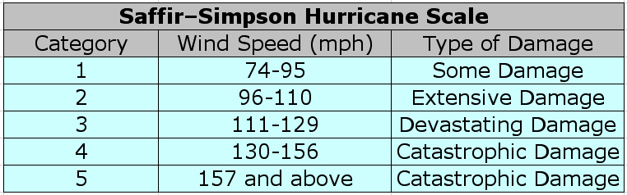

What is storm surge?
Storm surges are frequently the most devastating element of a hurricane. As a hurricane’s winds spiral around and around the storm, they push water into a mound at the storm’s center. This mound of water becomes dangerous when the storm reaches land because it causes flooding along the coast. The water piles up, unable to escape anywhere but on land as the storm carries it landward. A hurricane will cause more storm surge in areas where the ocean floor slopes gradually. This causes major flooding. Today’s technology allows forecasters to predict the amount of storm surge that will affect a coastal area. These are called Slosh Models and take into account a storm’s strength, its path, how the ocean shallows, and the shape of the land. Then it calculates how much storm surge a hurricane will probably cause.

Hurricane Statistics and Effects:
Recent years have seen an increase in the occurrence of hurricanes and their intensity. 2017 has been a record setting year for hurricanes. Hurricane Harvey (U.S. landfall on Aug 25, 2017) broke the U.S. record for rainfall from a single storm with over 51 inches of rain falling in parts of Texas causing widespread flooding. In addition, Harvey intensified much more rapidly than is usually seen, going from a Tropical Depression to a Category 4 hurricane in only 56 hours. 2017 was the first time that two major Atlantic hurricanes (Harvey and Irma) have made landfall in the U.S. in the same year and they were only two weeks apart. Hurricane Irma (U.S. landfall on Sept 10, 2017) was a record breaking hurricane in many ways. This was an incredibly massive and long lasting hurricane. Irma was a hurricane for over 11 days, longer than any other Atlantic hurricane. In addition, it was a Category 5 hurricane for over 3 days with sustained winds of 185mph for 37 hours, both record setting numbers. Irma grew to over 8oo miles wide, covering more than 70,000 square miles. This is larger than the entire state of Florida. Hurricane Irma and José were active in the Atlantic Ocean at the same time, the first time this has happened. Hurricane Maria also experienced explosive intensification and went from a Tropical Storm on Sept 16, 2017 to a Category 5 hurricane on Sept 18th. This year’s hurricanes caused the near total destruction of some island countries and total devastation in other places, like Puerto Rico, that will take years to recover from. Hurricanes cause fatalities in two ways, direct and indirect. Direct fatalities are the loss of life caused by the wind, rain or floods that the storm brings. Indirect fatalities are the loss of life that results from the conditions that the storm created, usually involving lack or power and access to medical care and clean, reliable sources of water and food. Hurricane Harvey claimed over 80 lives, Irma over 130, and Maria over 100 (this number is expected to climb much higher as areas that have been unreachable become accessible again and as indirect deaths climb due to the current conditions that exist in the places hit hardest). The financial effects of hurricanes can be tremendous. Economic losses come from loss of or damage to homes and businesses and also include revenue and crop losses. Economic losses for each of the three storms; Harvey, Irma and Maria, are expected to exceed $100 billion US dollars. 2016’s Hurricane Matthew was only a Category 1 storm when it reached NC, but the massive flooding it brought caused 28 fatalities and economic losses over 5 billion dollars in just North Carolina alone.

Hurricane Tracking

Follow the directions below to track Hurricanes Matthew and Harvey on the map in Station #1 in your packet.

Directions:
1. Plot the latitude and longitude of each hurricane for the days provided in the following data tables on the map found in your answer packet.
2. Write the date next to your plotted location.
3. For Tropical Storms use the color blue to plot these points.
4. For all categories of hurricanes use the color red to plot these points.
5. Connect each point for each storm with a line segment and arrow to show the direction of movement.
6. Label each path with the name of the hurricane.
7. When you have finished plotting the points for both hurricanes, answer the questions in your packet

Data:
Hurricane Matthew 2016
Date | Latitude (N) | Longitude (W) | Category on Saffir-Simpson Scale
9/29 | 14.0 | 65.0 | TS
9/30 | 14.0 | 71.0 | H3
10/1 | 14.0 | 75.0 | H4
10/2 | 15.0 | 75.0 | H4
10/3 | 17.0 | 76.0 | H4
10/4 | 18.0 | 75.0 | H4
10/5 | 22.0 | 75.0 | H3
10/6 | 24.0 | 77.0 | H4
10/7 | 29.0 | 80.0 | H3
10/8 | 33.0 | 78.0 | H1
10/9 | 34.0 | 73.0 | H1
Hurricane Harvey 2017
Date | Latitude (N) | Longitude (W) | Category on Saffir-Simpson Scale
8/24 | 24.4 | 93.6 | H1
8/24 | 25.2 | 94.6 | H1
8/25 | 25.9 | 95.4 | H2
8/25 | 27.1 | 96.3 | H3
8/25 | 28.0 | 97.0 | H4
8/26 | 28.2 | 97.0 | H3
8/26 | 28.9 | 97.3 | H1
8/26 | 29.1 | 97.6 | TS
8/26 | 29.3 | 97.3 | TS
8/27 | 29.3 | 97.4 | TS
8/27 | 29.2 | 97.7 | TS
8/27 | 29.0 | 97.6 | TS

