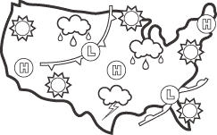**# _______**

**Reading Weather Maps and Forecasting Weather**

________________ __________ are used to show a variety of weather conditions in a particular area. They show _______________ weather conditions and are used to predict _____________ weather conditions.

________________ is the condition of the atmosphere outside at any given time. We need to understand weather because it impacts our daily activities, it impacts agriculture, transportation and commerce (what products are sold throughout the year).

Scientists who study and predict the weather are called _____________________________.

Their predictions are called _________________________.

Weather happens because the sun warms the Earth more near the equator than it does at the poles. This uneven heating causes large masses of air with different temperatures to form. As these air masses move, they cause changes in the weather.

Weather forecasting includes six main elements:

__________________________ __________________________

__________________________ __________________________

__________________________ __________________________

**Weather Instruments**

Meteorologists use a variety of tools to collect data in forecasting the weather.

|  |  |  |  |  |  |
| --- | --- | --- | --- | --- | --- |
| Measures air temperature  ____________  Thermometer clip art clipart star clipart arrow clipart apple | Measures wind speed  _____________  Image result for anemometer black and white | Measures wind direction  _____________  Related image | Measures air pressure  _____________  Image result for barometer black and white | Measures humidity  _______________  Image result for psychrometer black and white | Measures precipitation  ______________  https://images-na.ssl-images-amazon.com/images/I/510Qt-c2JrL._SL1000_.jpg |

|  |  |  |
| --- | --- | --- |
| Weather balloons are used to measure temperature, humidity and ______ ___________________. They are sent up twice a day to transmit weather data back to computers on the ground.  Weather Balloon  Image result for weather balloon | Radars monitor _____________, ________________, and _____________________.  Weather Radar  Image result for weather radar | __________________ _______________________ provide larger views of weather systems.  Weather Satellite  Image result for weather satellite black and white |

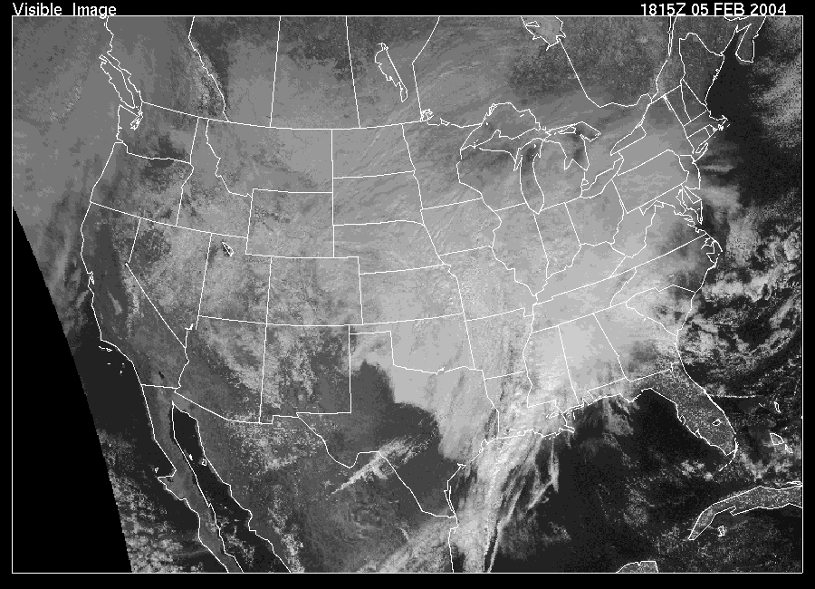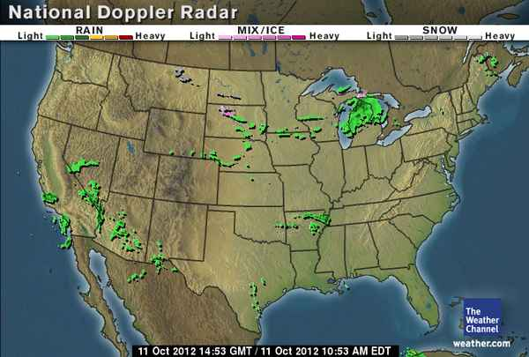

**Radar Image:** **Satellite Image:**

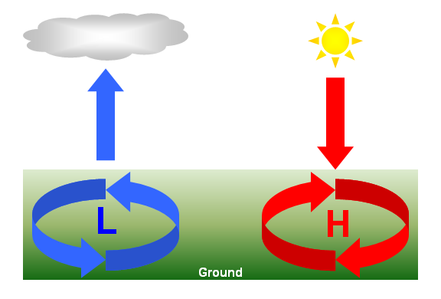

**Weather Maps**

Surface Maps can show pressure systems.

* The _______ stands for highs, or areas of high pressure.
* The letter ________ represents areas of low pressure, or lows.

Highs usually bring clear skies, and lows bring cloudy skies with possible precipitation. Highs and lows usually move from west to east across the United States, and bring changes in the weather as they pass.

* 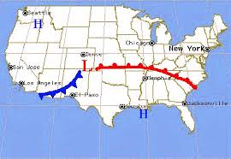Surface maps also show fronts.



Some maps show _____________________, or lines that join places

that have nearly the same temperature.

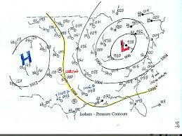

Lines that connect points of equal

air pressure are called

___________________.