Name: _____________________________________ Date:_________________ Core: _______ Item #:_________
Fronts Notes – Use the Nearpod to complete your notes, and then complete the practice on the back.

What is a front -

What is a Warm Front? -  Explain how air masses move to form a warm front: | What is a Cold Front-  Explain how air masses move to form a cold front:
Type of weather associated with a warm front: | Type of weather associated with a cold front:
Diagram of how air masses move in a warm front. (Please use color and arrows to indicate the temperature and movement of air masses.)  Weather Map Symbol for Warm Front  (Use appropriate color) | Diagram of how air masses move in a cold front. (Please use color and arrows to indicate the temperature and movement of air masses.)  Weather Map Symbol for Cold Front  (Use appropriate color)
What is a Stationary Front-  Explain how air masses move to form a stationary front: | What is an Occluded Front-  Explain how air masses move to form an occluded front:
Type of weather associated with a stationary front: | Type of weather associated with an occluded front:
Diagram of how air masses move in a stationary front. (Please use color and arrows to indicate the temperature and movement of air masses.)  Weather Map Symbol for Stationary Front  (Use appropriate color) | Diagram of how air masses move in an occluded front. (Please use color and arrows to indicate the temperature and movement of air masses.)  Weather Map Symbol for Occluded Front  (Use appropriate color)
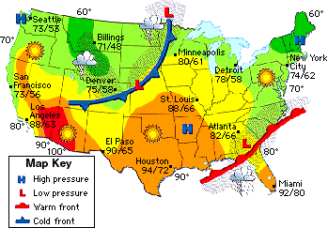
1.) Examine the map of the United States and locate the four cities named on your data table.
2.) After locating the cities, identify and describe the fronts heading towards each city and the air mass that follows it. (Use your notes to help recall types of air mass: continental polar, continental tropical, maritime polar, or maritime tropical.) Record this information in the data table.
3.) For each city, predict how the incoming front will change the weather (temperature and/or precipitation in that area.)
4.) Record your answers in the data table.

CITY, STATE  IN THE UNITED STATES | INCOMING FRONT  (Warm Front or Cold Front) | INCOMING  AIR MASS  How do you know?  (What’s your evidence from the map?) | EXPLAIN HOW THIS FRONT MIGHT CHANGE THE WEATHER AT THIS AREA?
 |  |  | TEMPERATURE | POSSIBLE WEATHER
St. Louis, Missouri
Houston, Texas
Atlanta, Georgia

Minneapolis Minnesota

