AOW 2: “Teens Who Believe They’ll Die Young Turn to Crime, Study Says”
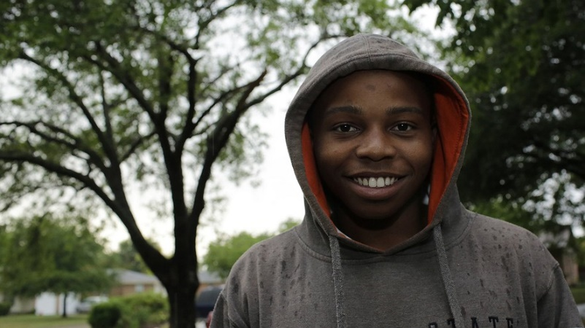
By Dallas Morning News, adapted by Newsela staff, 05/22/2014
When Jordan Henderson was 18 he was arrested for drug distribution. He has turned his life around and now sees a positive future. "I always thought it would be much better to be dead than in jail," he said in his Richardson, Texas, neighborhood on May 9, 2014.

DALLAS — Growing up in a North Dallas neighborhood plagued by drugs and gangs, Jordan Henderson envisioned just two options for his future: end up in jail — or the graveyard.
With little to look forward to, the 18-year-old began to pursue short-term successes, getting involved in drugs and criminal activity. He prayed that he’d live to see 21.
“We all like to think we can outsmart the system, but it never works out that way,” Henderson said. “We all end up in jail or dead. I always thought it would be much better to be dead than in jail.”
Henderson’s choices shouldn’t come as a surprise, according to a recent University of Texas at Dallas study that found that teens who believe they will die young are more likely to commit crimes — and more serious ones at that.
The study, released last month, asked more than 1,300 serious juvenile offenders in Arizona and Pennsylvania one question: How long do you think you’ll live? Their answers ranged from 16 to 200 years old. Researchers then checked in periodically with them over a period of seven years and asked about subsequent criminal activity.
The youths who went on to offend most were the ones with a short-term mentality. Notably, there was also a group of offenders — those who could think long term — who successfully reformed.
“What that tells us is you can’t just say all of these serious offenders are all bad and they’re all going to be bad forever,” said UTD criminologist Alex Piquero, who led the study.
Piquero said letting kids know “that your life now is not destiny” can make a difference.
“That’s the take-home policy message from this: It’s not a bleak thing,” he said. “We can turn some of these kids around if we give them these opportunities and we give them these consistent messages.”
For a long time, Henderson felt he had neither. All the adults he knew had no college education, and many dealt drugs to make money, he said. Earlier this year, Henderson was arrested for distribution of marijuana — a felony charge that’s pending.
“I basically had no visible hope,” he said. “I thought to myself, this is the lifestyle that everybody before me shows, this is the lifestyle that everyone around me is doing and this is the lifestyle I have to choose.
“I was involved in that lifestyle not by choice, but because I felt I was condemned to that lifestyle,” he said.
That’s a mentality that 15-year-old Merl Lovings of DeSoto can relate to. His father is serving a 15-year prison sentence for aggravated robbery with a deadly weapon, and he said he has a cousin his age who is in jail.
Lovings has toed the path toward a life of crime as well. Last year, he said he stole a BB gun from Wal-Mart with the intention of selling it. He planned to use the money to buy much-needed shoes for his brother.
“For the short term, man I was just like, if I do this I can get my brother some shoes and I can probably get an outfit or something,” said Lovings, who recently completed six months’ probation for theft. “But long term, I wasn’t really thinking about it.”
Lovings believes he’ll live to be about 50 or 60, but right now, he worries a lot about how to provide for his 6-year-old brother and 5-year-old sister. He recently began selling candy at school and around his apartment complex to contribute to the family’s income.
He spends less time focusing on his own future, a nebulous idea that might include joining the Navy or pursuing a rap career.
Piquero said that’s a typical dilemma for many juvenile offenders. “They have to basically survive today, and they can’t even think about 30 years from now,” he said.
Based on his study’s findings, Piquero said he hopes the government will do more to give disadvantaged teens opportunity to be productive citizens. That means a bigger emphasis on education and jobs, he said.
But he said parents and teachers — everyday role models — can also have a huge impact by consistently telling teens that success is possible and encouraging them to develop long-term goals.
“You have to say it and mean it,” Piquero said. “That’s a simple thing people can do, but the kids have to get the message consistently.”
Chad Houser has seen how the opportunity to do an honest day’s work, combined with a simple pat on the back, can make all the difference for disadvantaged juvenile offenders.
Houser is executive director of Dallas-based Cafe Momentum, a nonprofit restaurant that provides internships to young men coming out of jail. Since the program started in 2011, he said many offenders he works with go to school without textbooks — and go hungry worrying about their next meal. They live in neighborhoods overrun with trash, with guns around every corner.
In their world, an early death isn’t just a possibility — it’s a reality they accept. Houser said he’s never heard a teen talk about living beyond age 20.
But he watches the offenders’ attitudes transform with the chance to prepare food and serve guests at top-notch restaurants, such as Hibiscus or Cane Rosso.
For the first time in their lives, many feel a sense of approval and the joy that comes in living up to expectations. They begin to have something to live for — and work toward — instead of accepting their dismal circumstances as fate.
For example, Houser said one youth in the program has enrolled in college, began to cook dinner for his grandmother and recently wrote a 19-page book report on the book “The Outsiders.”
“It works in every case,” Houser said. “When you give them hope and encouragement and literally, as silly as it sounds, a pat on the back, a ‘good job,’ it changes their entire disposition.”
As for Henderson, his arrest turned out to be a decisive moment for his future. With a felony charge, he enrolled in Dallas County’s alternative education program, where he learned about a scholarship opportunity for college. He said he now has a full ride to Fisk University in Tennessee to look forward to.
Henderson’s life outlook has changed. He now hopes he can live into his 90s to see his children and even grandchildren take advantage of opportunities he never thought he had.
“I pray that I live to see the generational curse I’m so accustomed to be broken,” he said. “To be that difference maker, to be that one person who decided to make a change … that, to me, would be the hope I never got.”

