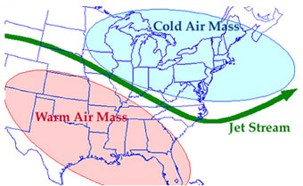
Name ________________________________
Date ____________________ #___________
Air Masses Notes
Part 1: Air Masses Basics
1. What is an air mass?

2. What provides an air mass with its characteristics?

3. Where do continental air masses originate?
Are they dry or moist air masses?

4. What do maritime air masses originate?
Are they dry or moist air masses?

5. Where do polar air masses originate?
Are they cold or warm air masses?

6. Where do tropical air masses originate?
Are they cold or warm/hot air masses?

7. List the abbreviation for each type of air mass, the kind of weather it brings and where it forms using the table below to record your answers.
Type of Air Mass | Kind of Weather it Brings  (warm or cold) | Kind of Weather it Brings  (moist or dry) | Where it Forms  (over land or over water) | Where it Forms  (at the poles or at the equator)
Continental Polar
________
Maritime Polar
________
Continental Tropical
________
Maritime Tropical
________

Part 2: Air Mass Visualizations
8. In the first illustration, what kind of air mass is passing over the region?

- What type of weather will it bring?

9. In the second illustration, what kind of air mass is passing over southern California?

- What type of weather will it bring?
Part 3: Labeling Air Masses
10. Using this map of North America, label the different air mass types that affect the USA and where these air masses come from. Include: continental polar, maritime tropical (Pacific), continental tropical, maritime tropical (Gulf of Mexico), maritime polar (Atlantic), maritime polar (Pacific).

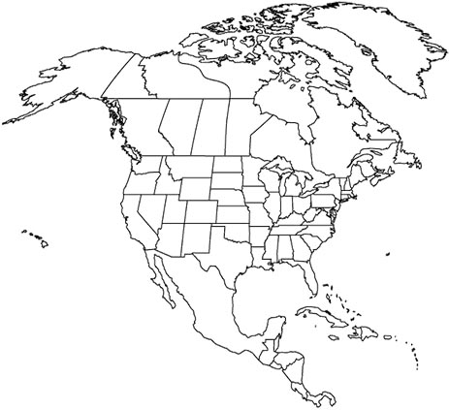

Part 4: Air Mass Movement
13. What major wind belts in the continental United States affect how air masses move? (Hint: Scroll down past the
map of the air masses to find the answer.)

What direction are the air masses generally pushed?

14. What additional fast-flowing stream of air effects air mass movement?

What direction does this stream of air flow?

Part 5: Identify the Air Mass

15. What type of air mass is Air Mass #1?

16. What type of weather will the Midwest experience from this air mass?

17. What type of air mass is Air Mass #2?

18. What type of weather will the southeast experience from this air mass?

